**2**. Creating a Serverless API\*\***

**Objective**: Develop a serverless API using AWS Lambda and API Gateway.

**Approach**:

* **Define API**: Design a simple RESTful API (e.g., for a todo list application).
* **Lambda Functions**: Create Lambda functions for each API method (GET, POST, PUT, DELETE).
* **API Gateway Setup**: Use API Gateway to set up the API endpoints, connecting each endpoint to the corresponding Lambda function.
* **Testing**: Test the API using tools like Postman or AWS API Gateway test functionality.

**Goal**: Gain hands-on experience in building and deploying a serverless API, understanding the integration between Lambda and API Gateway.

First create a Lambda function

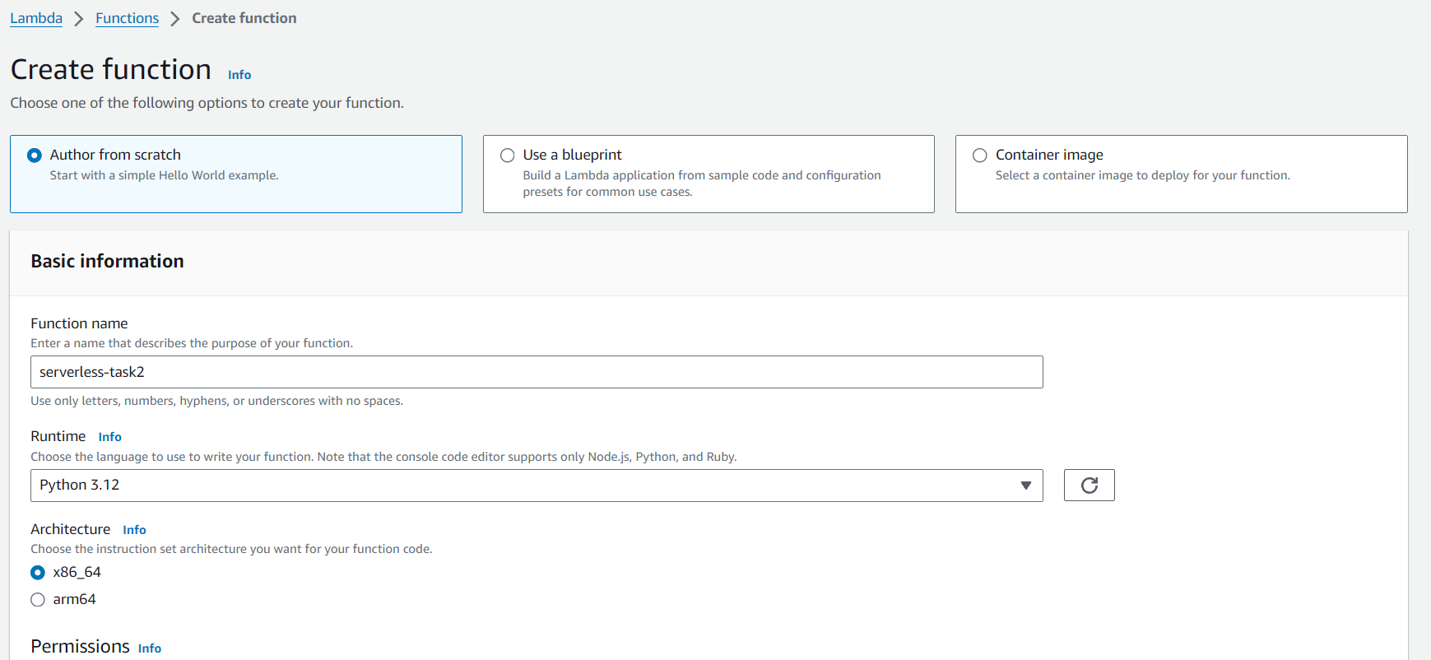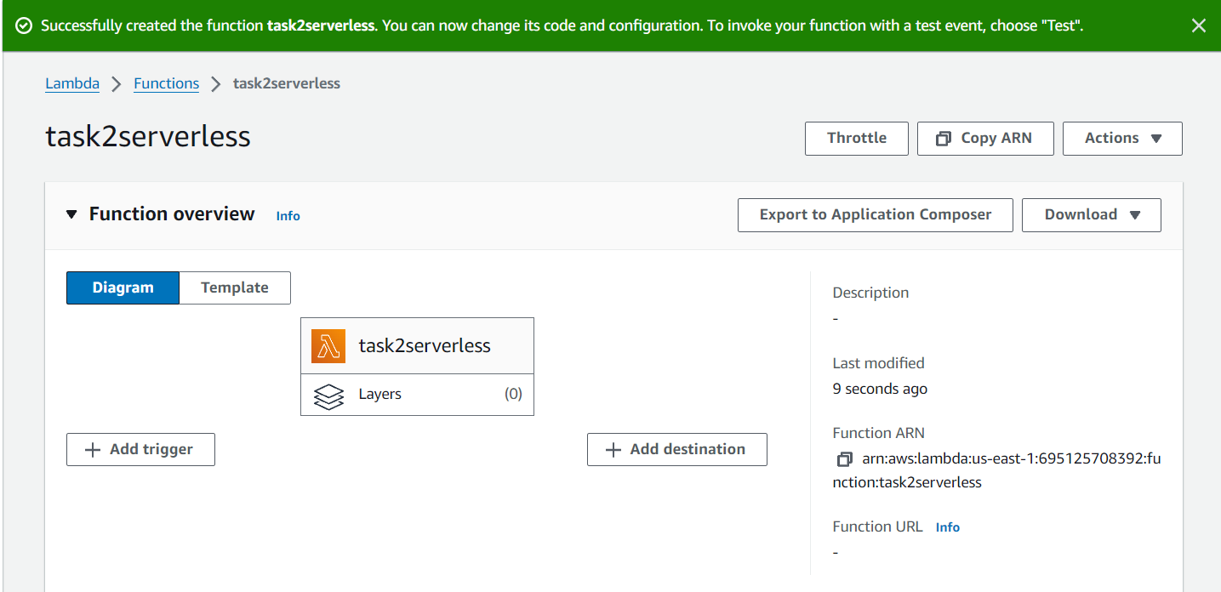

Now we will replace the lambda code the code that we created for todo list .

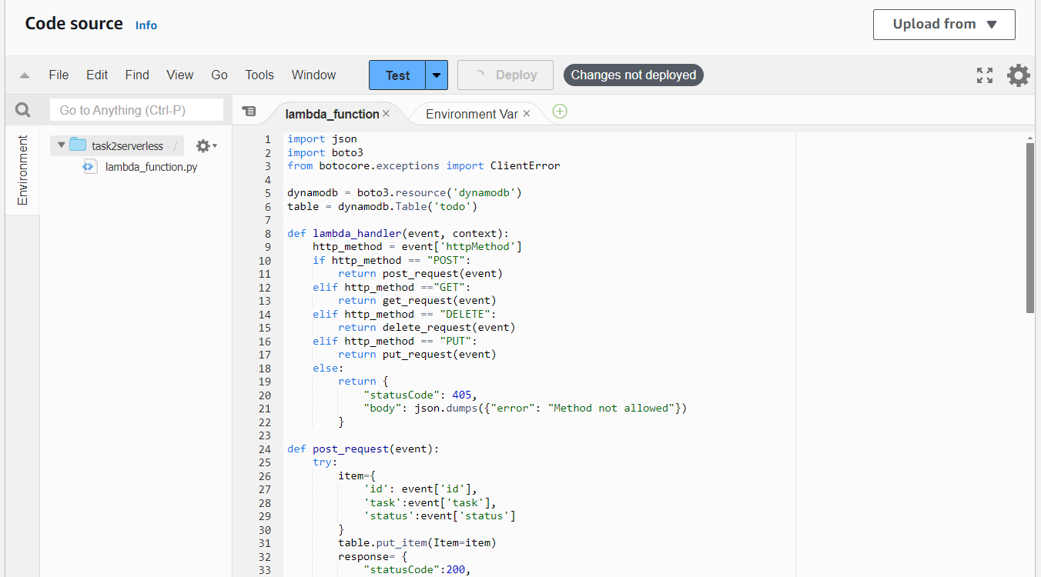

This code will be triggered whenever the api endpoints has been used,So now lets make a trigger using API gateaway.

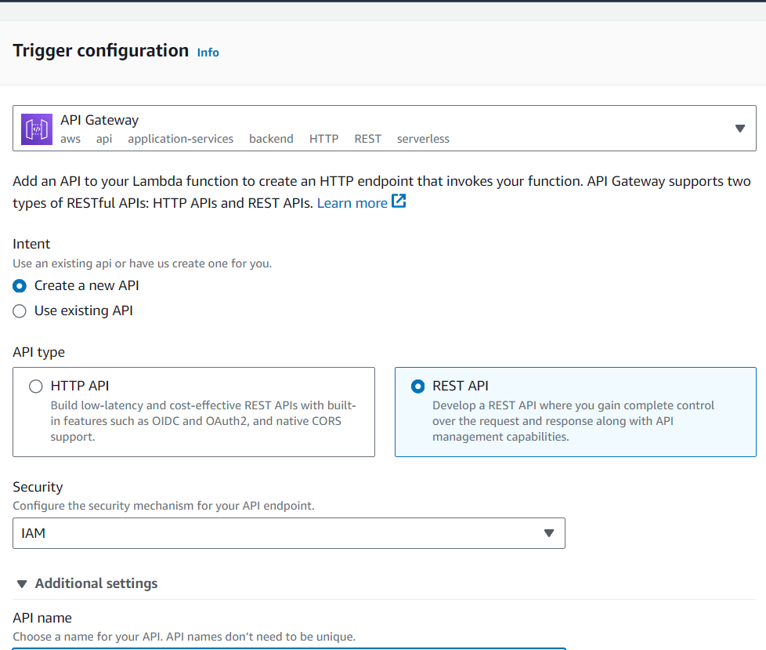

So after configuring API Gateway in our lambda , we can go to the API gateway trigger

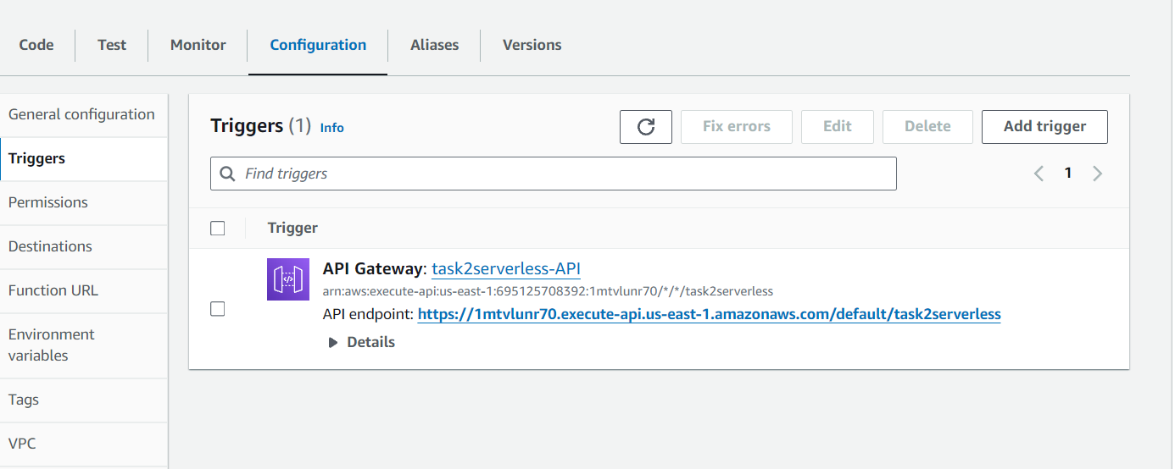

Then click on the link .It will redirect you to the new page AS api resources

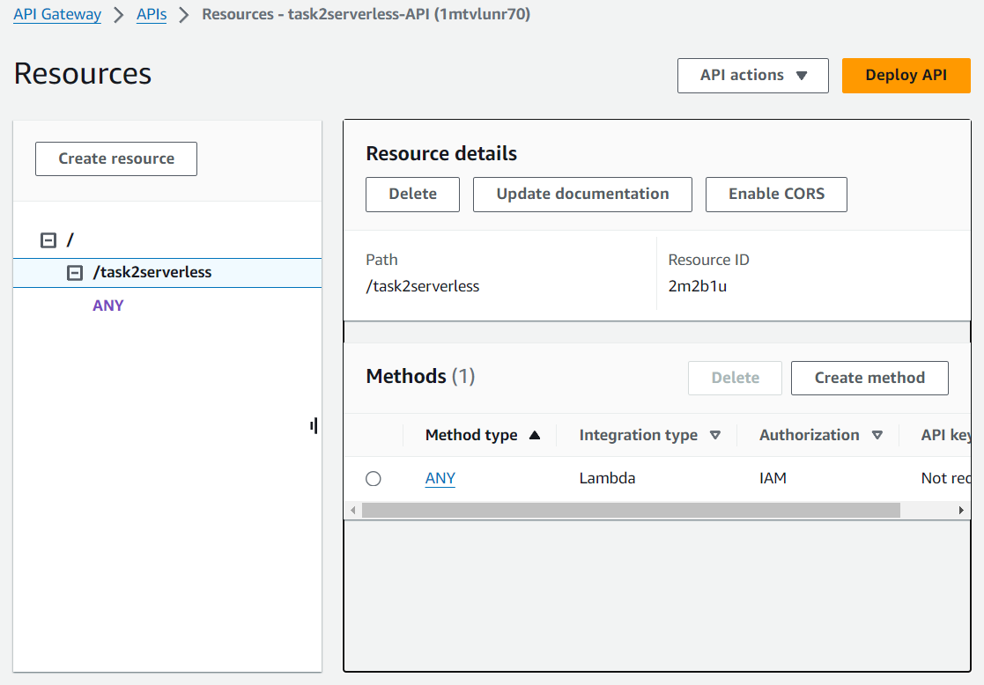

Then we create methods like get post put delete .

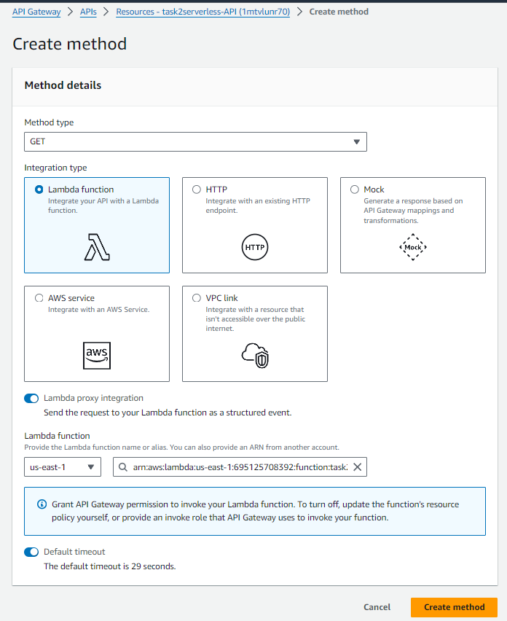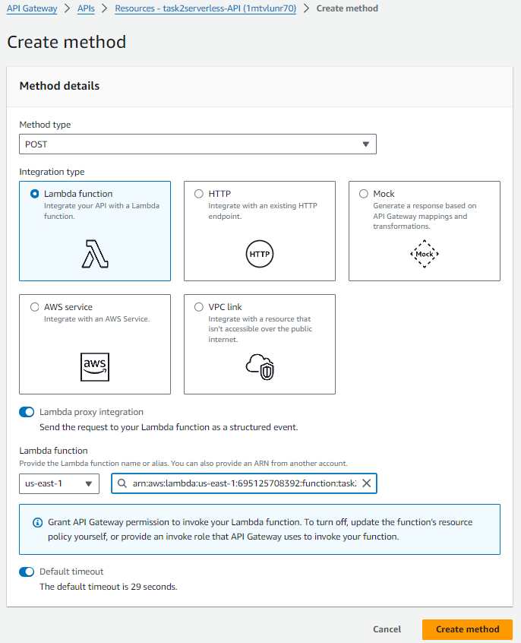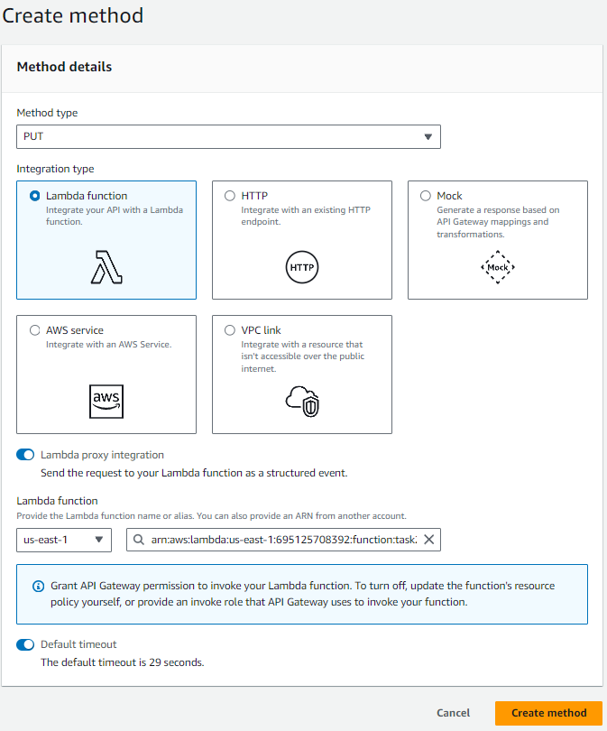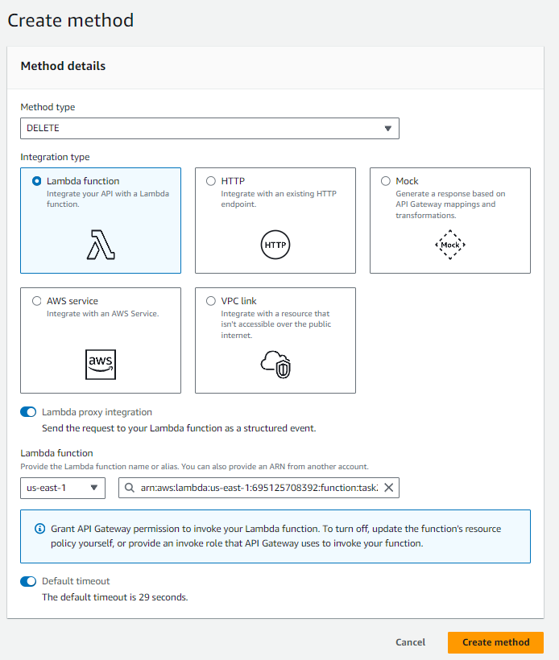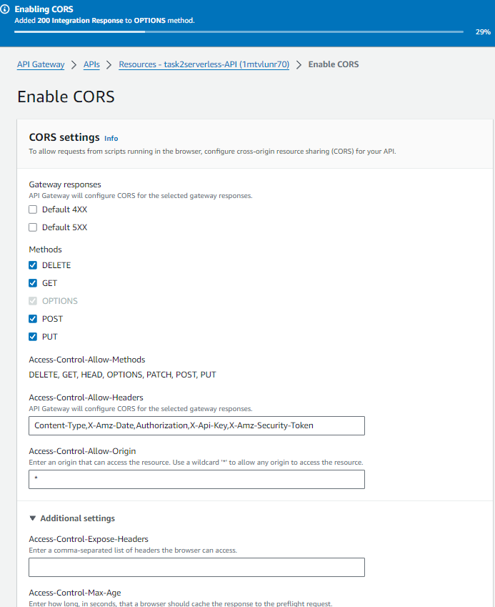

These are the list of Methods that we created, now we must deploy The API in a new Stage.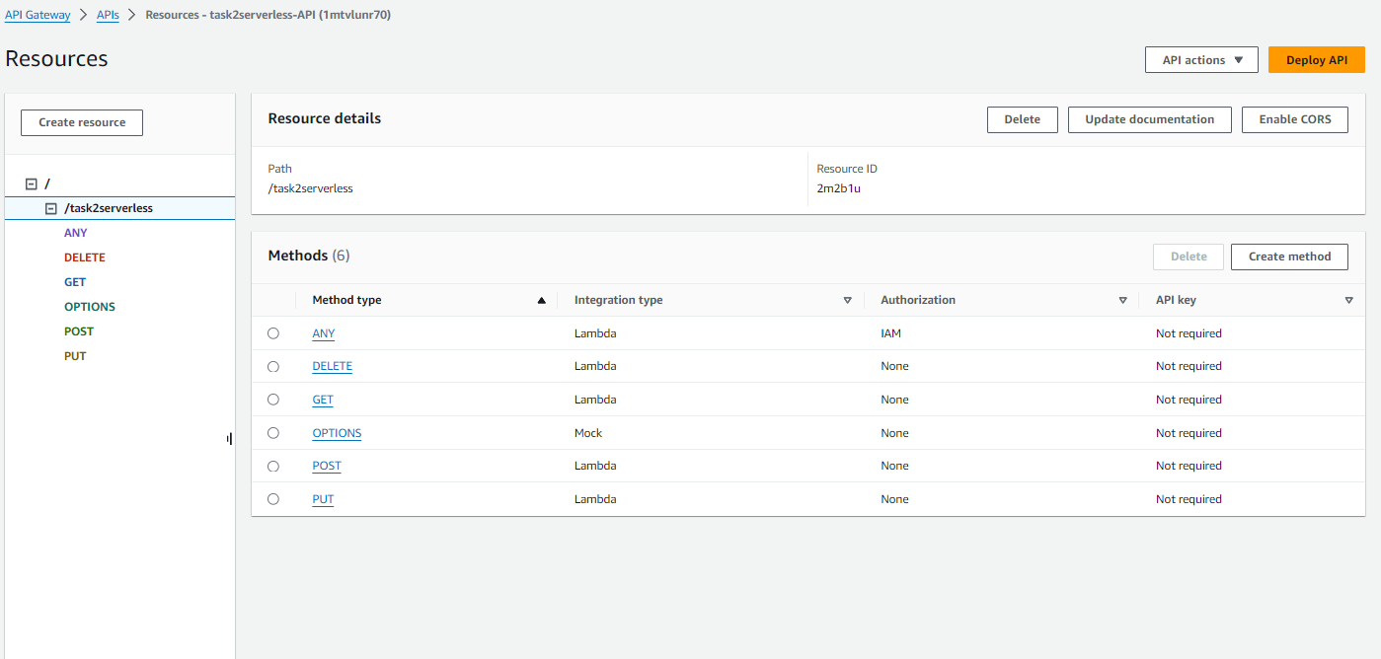

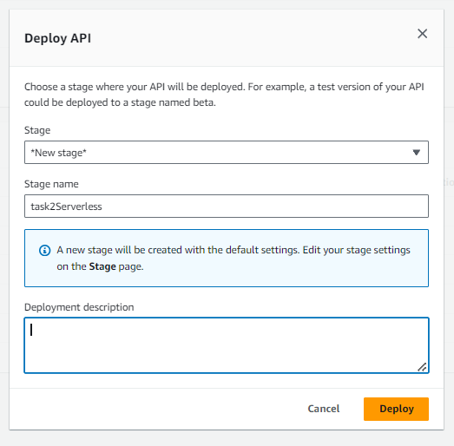

As you can see our api has been staged and if you click on Post or any other method it will show you the invoke URL that is a API url which is used to fetch datas.

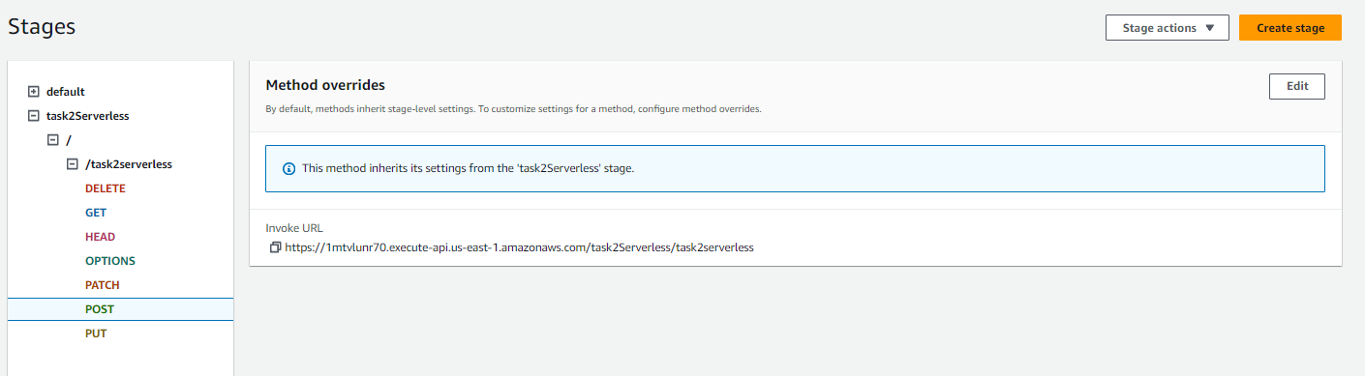

Now everything is setup, We just need a datatable or database , Using Dynamo DB , create a table

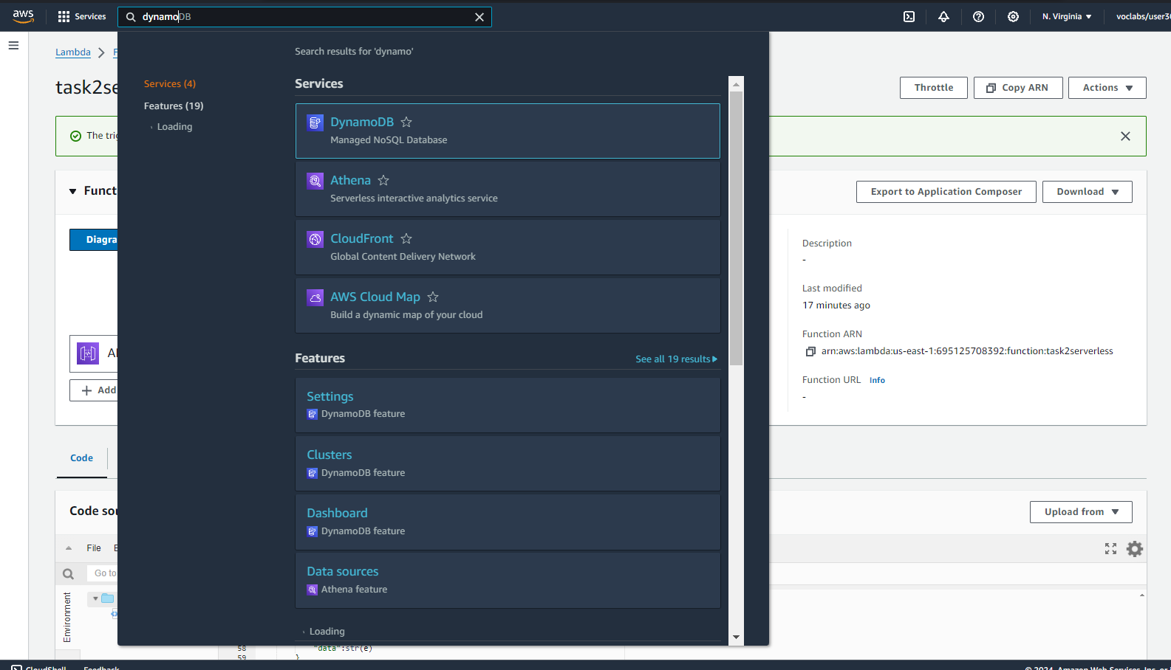

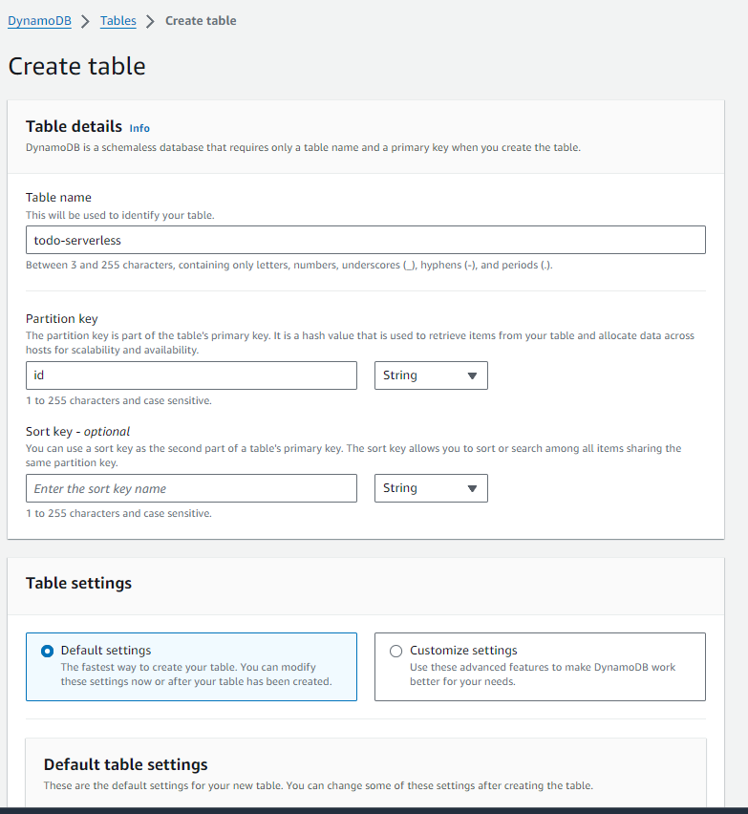 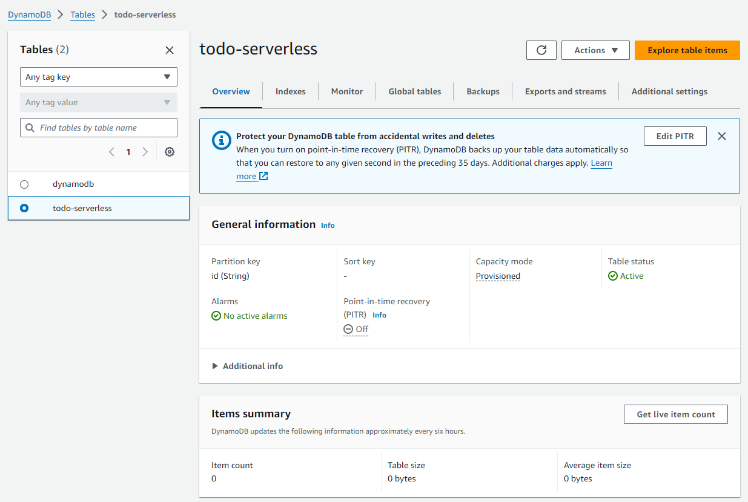

Implementation

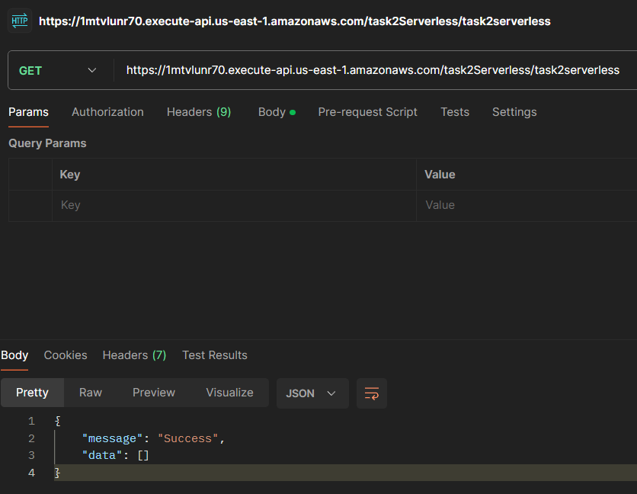

So as we can see API is working . We must implement this api to our frontend Todo List using simple website with HTML.

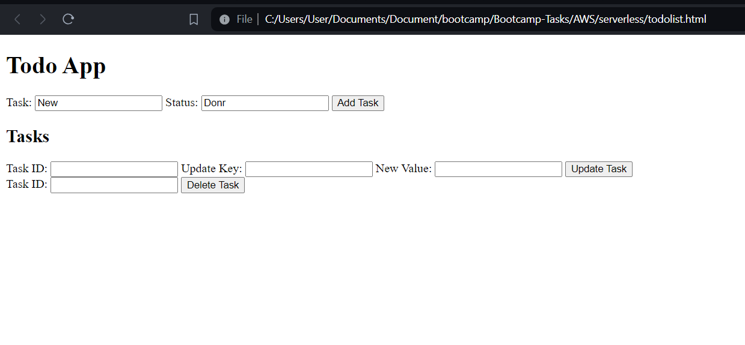

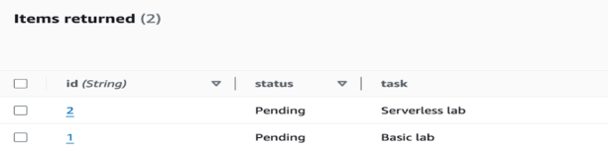

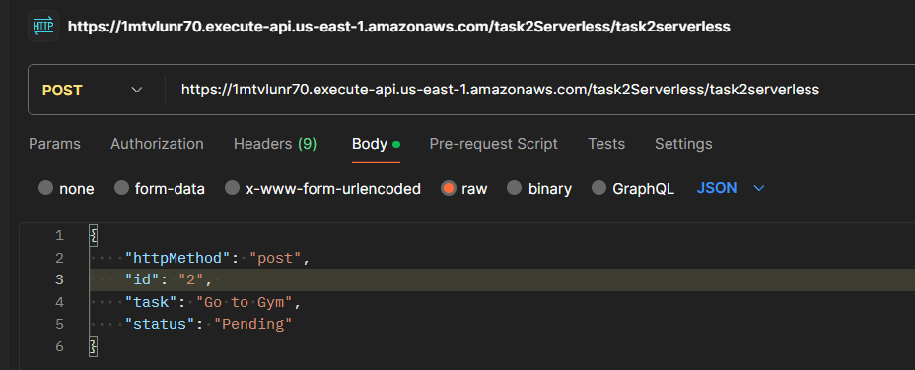Testing it in Postman app